

**Assessment of Effects of Water Level Changes on Lakes and Wetlands in the Central Florida Water Initiative Planning Area**

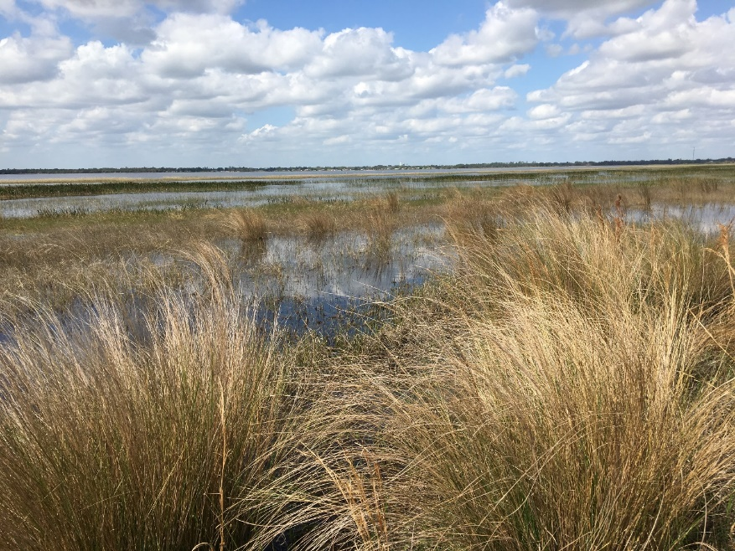

**Central Florida Water Initiative’s Environmental Measures Team**

**February 22, 2019**

**DRAFT REPORT**

# Table of Contents

1. Introduction and Background

Kym

1. Methodology Options for Wetlands and Lakes Analysis

Kym

3.0 2018 Assessment of Class 1 Wetlands

Kym, Kris H., Lisa

1. Determination of Class 1 Wetlands Water Level Data Period of Record for Wetlands Analysis

Kym and Kevin

The determination of the water level data period of record required that all the available data be preprocessed. This involved reformatting the available data as well as eliminating redundant or non-relevant data and creating data sets that were in a consistent form.

Historic water levels for each Class 1 Wetland were summarized to present P80 water levels for several date ranges. A series of date ranges for P80 water levels, all starting with 2006 and ending in 2011 through 2017, were graphed as line charts and helped determine that the most current data was representative of a non-extreme condition. An additional series of date ranges, all ending with 2017 and starting from 2006 through 2011, were graphed as line charts to help determine which period provided the longest record while not generally exhibiting a large deviation from the later years.

All date range P80 data sets ending in 2017 were analyzed using Shapiro-Wilkes test for Normality as well as presented as QQ plots to help identify outliers. A couple wetlands were determined to be outliers to a normal data set and excluded from the Class 1 wetlands. Date ranges 2009-2017 and 2010-2017 P80 rank results appeared to be very close and ultimately 2009-2017 was selected since it met the test for normality and had the longer period of record.

1. Wetlands Analysis

Kym, Kevin, and David

**Prepare and Compile water level data for each Class 1 wetland:**

Each District (SWFWMD, SJRWMD, and SFWMD) compiled spreadsheets of water level data for an initial list of Class 1 wetlands and collaborated on the table of Class 1 Wetland Survey results. ("Class 1 Wetland Info for Analysis ALLv1.xlsx")

* **SFWMD** provided three individual files for wetland areas (TibetButler, WalkerRanch, and SplitOak) having multiple stations per file and formatted with comma separated values (.csv) Lookup files were also provided for UTM Coordinates (meters) and CorpsCon Datum Adjustments from NGVD29 to NAVD88.
* **SJRWMD** provided Water level data in a single MS Excel workbook (“Class 1 Wetlands NAVD 88.xlsx”) with 17 tabs (or worksheets) for each station with water levels reported as NAVD 88.
* **SWFWMD** provided 36 MS Excel workbooks, many with multiple “Site ID”s (each on separate tabs or worksheets). Initially all stations had hydrographs plotted and information reviewed to determine which tab was the most representative Site ID for a wetland. Original data sets were backed-up and extraneous tabs removed from the spreadsheets. Several sites had data reported in NAVD88. Those with water levels reported as NGVD29 required identification of a “datum shift” value to be applied to each water level value in a formula within each spreadsheet prior to further processing.

**Interpolate Missing Data:**

Since many of the stations had missing data or differing reporting frequencies it was determined that these gaps (in daily frequency) should be imputed or filled using linear interpolation. Unbounded periods of missing data were not extrapolated and left as missing.

The programming language “R” was used to develop scripts to process the data. These scripts provide a means to repeatedly and consistently process all the available wetland input data and each series of model runs very quickly. They also provide a way to reprocess all the data as new model runs, new data, updates or corrections to data, and/or elimination of stations took place. And finally, they provide a clear and detailed set of documentation of the processing steps, someone with a programming background can use in the future.

**Process the Data:**

Three similar scripts were created to perform the initial processing of the water level data. (WetlandStressSFWMDsYr.R, WetlandStressSWFWMDsYr.R, WetlandStressSJRWMDsYr.R)

The purpose of these scripts:

1. Compile the data from multiple sources into data sets which can be merged
2. Fill in missing data
3. Calculate P80 levels, for each wetland and for multiple date ranges
4. Create graphs for each Wetland
   1. Line Charts of P80 Rank Water Levels comparing date ranges
   2. Histograms of Water Levels
   3. Timeseries Hydrographs of available Water Levels for 2006 thru 2017

**Calculate Models for Probable Change in Stress:**

Calculate probability of stressed wetlands becoming unstressed and unstressed wetlands becoming stressed for a range of values representing an imposed change of hydrologic index values () for a range of initial values of .

An additional program (ZetaCalcIntegrals.R) was developed to evaluate the data compiled from the initial scripts and wetland stress criteria from wetland surveys to compute Zetas (see *docs*) as integral functions which can be used to predict probable change in stressed acres. This program generates “*zetaModels”* (equivalent to 9th order polynomial equations) which are used by P80headDiffProbabilities.R.

A final program P80headDiffProbabilities.R processes two Modflow model binary heads data files to produce two arrays of “P80 Heads” (“Reference Condition” and “Future Simulation”), calculated cell by cell for a single layer as the 80th percentile rank over the period of the model simulation (133 monthly stress periods). The difference in these two arrays represent the imposed change of hydrologic index values () for a model layer (Layer 1 representing the Surficial Aquifer and Layer 3 for the Upper Floridan Aquifer) with values for each model cell in the processed layer.

These are used as input to the “zetaModels” to create probability matrices for each combination of wetland physiographic type and initial stress status. The matrices are intersected with wetland points for class 1, 2, and 3 and the acres represented in the intersected model cell are multiplied by the Zeta to produce the acres of change in wetland stress by wetland type (ridge or plain) from stressed to unstress and from unstressed to stressed. The results are provided as maps and raster datasets of net change in stressed acres for wetland model cells influenced by Surficial Aquifer and Upper Floridan Aquifer water level differences. Tables of results are also produced summarizing change in stress acres by wetland Class (1, 2, 3), physiographic regions (plain or ridge) as well as initial stress status (stressed or not stressed)

*\*docs = “Development of a Statistical Predictor of Wetland Stress Caused by Alteration of Surface Water Levels, by David F. MacIntyre, P.E., August 2014”*

1. Summary

Kym

1. References

Kym

# 1.0 Introduction and Background

The Environmental Measures Team (EMT), a subteam of the Water Resources Assessment Team (WRAT), is a technical support group consisting of scientists from three water management districts – South Florida Water Management District (SFWMD), St. Johns River Water Management District (SJRWMD), and Southwest Florida Water Management District (SFWMD) – and public supply utility representatives which performs environmental assessments of wetlands and surface waters and other related work in support of determining sustainable groundwater withdrawals in the Central Florida Water Initiative (CFWI) planning area. The EMT currently consists of the following members:

* Kym Rouse Holzwart – EMT Chair and SWFWMD representative
* David MacIntyre – EMT Co-Chair and environmental consultant (AquaSciTech Consulting) representing St. Cloud, TOHO Water Authority, Orange County, Polk County, and Reedy Creek Improvement District (STOPR)
* Shirley Denton – Environmental consultant (Cardno) representing Orlando Utilities Commission (OUC)
* Kristian Holmberg – SJRMWD Representative
* Lisa Prather – SFWMD Representative
* Kevin Rodberg – SFWMD Representative

For the 2015 CFWI Regional Water Supply Plan (RWSP), the EMT’s evaluation of wetlands and lakes, most without adopted minimum flows and levels (MFLs), within the CFWI planning area was an integral component. The EMT was tasked with determining the current status of isolated wetlands and lakes with respect to hydrologic stress and alteration and to develop tools to evaluate modeled future wetland conditions within the CFWI planning area.

Between 2007 and 2012, over 350 primarily isolated wetlands and lakes within and near the CFWI planning area were visited and assessed by consultants for the Central Florida Coordination Area (CFCA) team, the predecessor to the CFWI (CFWI EMT 2013). The CFCA team met to review the consultant’s reports, evaluate aerial photographs, and categorize the wetlands as Stressed or Not Stressed. The EMT conducted field visits to re-evaluate proposed Class 1 wetlands. The wetlands and lakes were divided into three classes based on the amount of information available; each wetland class is described below.

* Class 1 wetlands: These 44 wetlands and lakes were studied in detail. The hydrologic conditions were known (long-term water level data and wetland edge elevation), and they were assessed to determine whether they were stressed or unstressed.
* Class 2 wetlands: This class includes approximately 200 wetlands and lakes where the environmental condition of the wetland was known, but there was insufficient water level data to assess the hydrologic conditions.
* Class 3 wetlands: Thousands of isolated wetlands and lakes within the CFWI planning area are included in this class; neither the water levels nor the stress conditions were known.

For the 2015 CFWI RWSP, the method used to evaluate wetlands under future modeled water level conditions was based on evaluations of primarily isolated lake and wetland systems, which are generally considered to be inherently more vulnerable to impacts from lowered groundwater levels (CFWI EMT 2013). The recent stress condition of a select group of assessed wetlands was examined. The methodology was based on a statistical assessment of the probability of future environmental stress in each wetland within and near the CFWI planning area based upon the relationship between observed ecologic and hydrologic conditions of the 44 Class 1 wetlands. The water level data from the Class 1 wetlands were used to compute a statistical relationship between observed stress and observed water level variations. The statistical relationship was used to estimate the probability (or risk) of future changes in wetland stress occurring, based on modeled water level changes between the reference condition and a future groundwater withdrawal scenario. This risk assessment was applied separately to primarily isolated wetlands in Plains and Ridges physiographic settings because wetland hydrologic conditions and responses in these wetland types are in general, substantially different. Statistical analyses were performed, which indicated that the characteristics of the Class 1 wetlands were adequately representative of all isolated wetlands in the CFWI planning area and that the data used were appropriate for their application. This set of tools was used by the Groundwater Availability Team (GAT) to predict likely effects of future groundwater withdrawals, as predicted by modeled water levels, on wetland resources.

Once the 2015 CFWI RWSP was completed, the EMT became inactive. However, it was reactivated in late 2016 to provide support for the 2020 update to the RWSP as it relates to non-MFL isolated wetlands and lakes. Described below are the tasks that were completed and analyses that were conducted to assess the impacts of future groundwater withdrawals in the CFWI planning area on wetlands and lakes in support of the update to the CFWI RWSP.

# 2.0 Methodology Options for Wetlands and Lakes Analysis

One option for assessing the current condition of wetlands and lakes in the CFWI planning area was to re-evaluate a valid subset of the approximately 200 Class 2 wetlands to determine if their environmental conditions had changed since their original evaluation. Therefore, the EMT performed a statistical power analysis to determine the number of wetlands that would need to be re-evaluated to obtain a statistically significant determination of any change in the number of stressed wetlands within the CFWI planning area. Based on the recent experience of examining wetlands in the CFWI planning area, EMT wetland scientists estimated that there might be a shift towards a smaller percentage of wetlands being stressed, but that the change in percentage of stressed wetlands over the last five years was not large (probably measured in single digit percentages).

The results of the statistical power analysis indicated that a population greater than the original sample pool of Class 2 wetlands would need to be evaluated to provide a statistically significant conclusion at a 90% or 95% confidence level on whether a change on the order of 10% of wetlands had changed stress status since the last survey of Class 2 wetlands. When these results were presented to the WRAT, they requested that the EMT develop options for determining the current status of isolated wetlands and lakes with respect to hydrological stress and to evaluate modeled future wetlands conditions in support of the 2020 CFWI RWSP. The EMT presented various options to the WRAT, and the methodology option approved by the WRAT and Management Oversight Committee (MOC) and presented to the Steering Committee included:

* Conducting field visits to assess the current stress status of the original 44 Class 1 wetlands using primarily the same methodology that was used in support of the analyses for the 2015 CFWI RWSP;
* Adding new wetlands to the Class 1 wetland dataset; and
* Using the same methodology to conduct the wetlands analysis that was used for the 2015 CFWI RWSP with the expanded Class 1 wetlands dataset and updated ECFTX model.

The sections that follow describe the methods and results associated with the approved methodology option described above.

# 3.0 2018 Assessment of Class 1 Wetlands

**3.1 Methods**

Compared to the methodology used for the original assessments that were conducted from 2007 through 2012, key changes were made to the methodology used for the 2018 assessments, which are described in the following bullets.

* The original assessments were performed by a large number of consultants with varying skill levels. To ensure consistency and minimize variability, three wetland scientists on the EMT from each water management district with significant experience assessing wetlands conducted all the assessments. As an additional measure to ensure consistency, a joint field day was held by the water management district EMT wetland scientists on April 19, 2018, and stress status assessments of eight Class 1 wetlands were conducted collaboratively.
* The original assessments were based on change from historical conditions, which was highly variable. For the current assessments, historical changes that occurred prior to the 1980s that were not consistent with observed current conditions were not utilized as the sole determinant of current stress.
* The original field form required the collection of information that was not related to hydrologic stress. The field form used for the original wetland status assessments was revised, simplified, and field tested by water management district EMT wetland scientists to collect data related only to hydrologic stress (Appendix A).

The Class 1 wetlands for which field assessments were conducted include four original sites and three new wetlands in the SFWMD, 14 original and four new sites in the SJRWMD, and 26 original sites and nine new wetlands in the SWFWMD (Table 1). The new wetlands in the SFWMD portion of the CFWI planning area consist of two additional wetlands at Walker Ranch and one at Split Oak. Two of the new sites in the SJRWMD were originally assessed for the EMT evaluation for the 2015 RWSP (Lake Sylvan and Prairie Lake); however, they were not included in the original Class 1 wetland dataset. The other two new SJRWMD sites (Red Bug Lake and Chapman Marsh) are in urbanized areas. The nine new wetlands in the SWFWMD portion of the CFWI planning area include two additional wetlands in the Green Swamp, one wetland in the SWFWMD’s Alston Tract of the Upper Hillsborough Preserve, three wetlands in the City of Lakeland’s Northeast Wellfield, one wetland in the Florida Fish and Wildlife Conservation Commission’s Lake Wales Ridge Wildlife and Environmental Area, Mountain Lake Cutoff Tract, and two wetlands that are monitored for Polk County wellfields, one in Haines City near I-4 and one on the Nature Conservancy’s Saddle Blanket Scrub Preserve. Appendix C contains information on all of the Class 1 wetlands that were assessed.

Field work assessing the majority of Class 1 wetlands was completed in early June 2018. The EMT water management district wetland scientists met in mid-June 2018 to finalize the results of the stress status assessments by reviewing the field forms, photographs, water level data, a time series of aerial photographs, and previous assessment results. Discussion during the June meeting focused on sites for which the stress status changed since the original assessment; however, sites that remain unchanged were also discussed for consensus. Stress status assessments were conducted at five potential new Class 1 wetlands in August and September 2018, and data for these sites were also reviewed. Additional data review continued through 2018, and the final expanded Class 1 wetland dataset includes 41 of the original 44 sites and 15 new sites (Figure 1).

**Table 1. Site descriptions of the original 44 and 16 new Class 1 wetlands that were assessed.**

|  |  |  |  |  |  |  |
| --- | --- | --- | --- | --- | --- | --- |
| **District** | **EMT ID** | **Site Name** | **Physiographic Region** | **Wetland Hydroclass** | **Longitude** | **Latitude** |
| SFWMD | SF-YK | Tibet Butler | Plains | 1A Depressional Mesic | -81.537112 | 28.446165 |
| SFWMD | SF-LA | Walker Ranch - WR11 | Plains | 1A Depressional Mesic | -81.404507 | 28.083626 |
| SFWMD | SF-LB | Walker Ranch - WR6 | Plains | 1A Depressional Mesic | -81.412562 | 28.113903 |
| SFWMD | SF-XZ | Walker Ranch - WR9 | Plains | 1A Depressional Mesic | -81.418795 | 28.109258 |
| SFWMD | SF-N11 | Walker Ranch WR-16 | Plains | 1A Depressional Mesic | -81.392284 | 28.077793 |
| SFWMD | SF-N21 | Walker Ranch WR-15 | Plains | 1A Depressional Mesic | -81.390062 | 28.082236 |
| SFWMD | SF-WT1 | Split Oak | Plains | 1A Depressional Mesic | -81.2089024 | 28.358426 |
| SJRWMD | SJ-AJ2 | Lake Gem | Plains | 1E Flatland Lakes | -81.207313 | 28.645854 |
| SJRWMD | SJ-LA | Unnamed Cypress | Plains | 1A Depressional Mesic | -81.119700 | 28.566632 |
| SJRWMD | SJ-LB | Unnamed Wetland Nr SR 46 | Ridge | 1E Flatland Lakes | -81.360359 | 28.810519 |
| SJRWMD | SJ-LC | Boggy Marsh | Plains | 2D Strands/Sloughs (but hydrologically isolated by roads and crossings) | -81.697514 | 28.396950 |
| SJRWMD | SJ-LD | Hopkins Prairie | Ridge | 1F Xeric Lakes | -81.693251 | 29.274910 |
| SJRWMD | SJ-LE | Lake Avalon | Ridge | 1F Xeric Lakes | -81.642740 | 28.510180 |
| SJRWMD | SJ-LF | Lake Apshawa | Ridge | 1F Xeric Lakes | -81.773330 | 28.599640 |
| SJRWMD | SJ-LH2 | Island Lake | Plains | 2A-M Large Isolated | -81.363091 | 28.696596 |
| SJRWMD | SJ-LI | Lake Sylvan | Plains | 1E Flatland Lakes | -81.379811 | 28.803797 |
| SJRWMD | SJ-LL | City of Cocoa, Well 9T | Plains | 2D Strands/Sloughs (but hydrologically isolated by roads and crossings) | -81.053314 | 28.394303 |
| SJRWMD | SJ-QA | Church Lake | Ridge | 1F Xeric Lakes | -81.841699 | 28.644937 |
| SJRWMD | SJ-QB | Johns Lake | Ridge | 1F Xeric Lakes | -81.657585 | 28.531825 |
| **Table 1. Site descriptions of the original 44 and 16 new Class 1 wetlands that were assessed (cont.).** | | | | | | |
| **District** | **EMT ID** | **Site Name** | **Physiographic Region** | **Wetland Hydroclass** | **Longitude** | **Latitude** |
| SJRWMD | SJ-QC | Trout Lake | Ridge | 1F Xeric Lakes | -81.712212 | 28.447999 |
| SJRWMD | SJ-QD | Long Lake | Ridge | 1F Xeric Lakes | -81.469958 | 28.617014 |
| SJRWMD | SJ-LJ1 | Lake Louisa | Ridge | 2G Floodplain Lakes (but regulated) | -81.74695 | 28.46346 |
| SJRWMD | SJ-GA1, 2 | Prairie Lake | Ridge | 1F Xeric Lakes | -81.5113 | 28.59775 |
| SJRWMD | SJ-N11 | Red Bug Lake | Plains | 1E Flatland Lakes | -81.290839 | 28.648639 |
| SJRWMD | SJ-N21 | Chapman Marsh | Plains | 2A-M Large Isolated | -81.193906 | 28.641028 |
| SWFWMD | SW-LE | Cypress Creek #199, W17 Sentry Wetland | Plains | 1A Depressional Mesic | -82.394478 | 28.286128 |
| SWFWMD | SW-LF2 | Cypress Creek #190 E Marsh | Plains | 2A-M Large Isolated | -82.378218 | 28.304856 |
| SWFWMD | SW-LG | Cypress Creek #223 B W46 | Plains | 1A Depressional Mesic | -82.391208 | 28.290439 |
| SWFWMD | SW-LH | Cypress Creek #211 W33 | Plains | 2A-M Large Isolated | -82.393056 | 28.276317 |
| SWFWMD | SW-AA | Green Swamp #7 | Plains | 1A Depressional Mesic | -81.911111 | 28.312611 |
| SWFWMD | SW-LI | Green Swamp Marsh #304 | Plains | 1A Depressional Mesic | -82.017890 | 28.354863 |
| SWFWMD | SW-LJ | Green Swamp #6, #303 | Plains | 1A Depressional Mesic | -81.971260 | 28.394560 |
| SWFWMD | SW-LK | Green Swamp #5, #302 | Plains | 1A Depressional Mesic | -82.018658 | 28.368859 |
| SWFWMD | SW-LM | Green Swamp #1, #298 | Plains | 1A Depressional Mesic | -81.946755 | 28.361410 |
| SWFWMD | SW-JJ | Lake Garfield | Ridge | 1A Depressional Mesic | -81.723410 | 27.900860 |
| SWFWMD | SW-MM | Lake Wales | Ridge | 1F Xeric Lakes | -81.578690 | 27.903910 |
| SWFWMD | SW-QA | Big Gum Lake | Ridge | 1F Xeric Lakes | -81.492193 | 27.928229 |
| SWFWMD | SW-QB | Bonnet Lake | Ridge | 1F Xeric Lakes | -81.438926 | 27.546476 |
| **Table 1. Site descriptions of the original 44 and 16 new Class 1 wetlands that were assessed (cont.).** | | | | | | |
| **District** | **EMT ID** | **Site Name** | **Physiographic Region** | **Wetland Hydroclass** | **Longitude** | **Latitude** |
| SWFWMD | SW-QC | Buck Lake | Ridge | 1F Xeric Lakes | -81.332671 | 27.234785 |
| SWFWMD | SW-QD | Gator Lake | Ridge | 1F Xeric Lakes | -81.686616 | 27.841225 |
| SWFWMD | SW-QE | Lake Annie | Ridge | 1F Xeric Lakes | -81.351758 | 27.205947 |
| SWFWMD | SW-QF | Lake Apthorpe | Ridge | 1F Xeric Lakes | -81.362716 | 27.344290 |
| SWFWMD | SW-QH | Lake Leonore | Ridge | 1F Xeric Lakes | -81.512255 | 27.793753 |
| SWFWMD | SW-QI | Lake Placid | Ridge | 1F Xeric Lakes | -81.364219 | 27.244505 |
| SWFWMD | SW-QJ | Lake Streety | Ridge | 1F Xeric Lakes | -81.569989 | 27.678406 |
| SWFWMD | SW-QK | Lake Van | Ridge | 1F Xeric Lakes | -81.768938 | 28.107150 |
| SWFWMD | SW-QL | Lake Walker | Ridge | 1F Xeric Lakes | -81.717885 | 27.853656 |
| SWFWMD | SW-QM | Polecat Lake | Ridge | 1F Xeric Lakes | -81.699882 | 27.843913 |
| SWFWMD | SW-QN | Surveyors Lake | Ridge | 1F Xeric Lakes | -81.691552 | 27.833970 |
| SWFWMD | SW-QO | Parks Lake | Ridge | 1F Xeric Lakes | -81.468410 | 27.915700 |
| SWFWMD | SW-QQ | Crooked Lake | Ridge | 1E Flatland Lakes | -81.553030 | 27.827970 |
| SWFWMD | SW-N11 | Green Swamp Bay | Plains | 2A-M Large Isolated | -81.9537 | 28.4218 |
| SWFWMD | SW-N21 | Green Swamp #4 | Plains | 1A Depressional Mesic | -81.9311 | 28.3919 |
| SWFWMD | SW-N31 | Alston Bay | Plains | 2A-M Large Isolated | -82.0906 | 28.1804 |
| SWFWMD | SW-N41 | NE Lakeland Wellfield G | Plains | 2A-M Large Isolated | -81.9027796 | 28.170354 |
| SWFWMD | SW-N51 | NE Lakeland Wellfield J | Plains | 2A-M Large Isolated | -81.8883 | 28.1652 |
| SWFWMD | SW-N61 | NE Lakeland Wellfield K | Plains | 1A Depressional Mesic | -81.8962 | 28.161 |
| **Table 1. Site descriptions of the original 44 and 16 new Class 1 wetlands that were assessed (cont.).** | | | | | | |
| **District** | **EMT ID** | **Site Name** | **Physiographic Region** | **Wetland Hydroclass** | **Longitude** | **Latitude** |
| SWFWMD | SW-N71 | Van Fleet #2 | Plains | 1A Depressional Mesic | -81.6634 | 28.2422 |
| SWFWMD | SW-N81 | Saddle Blanket Scrub #2 | Ridge | 1B Depressional Xeric | -81.5788 | 27.6706 |
| SWFWMD | SW-N91 | Lake Wales Ridge WEA #1 | Ridge | 1B Depressional Xeric | -81.595412 | 27.923136 |

1: Denotes new Class 1 wetland

2: Not included in final, expanded Class 1 dataset

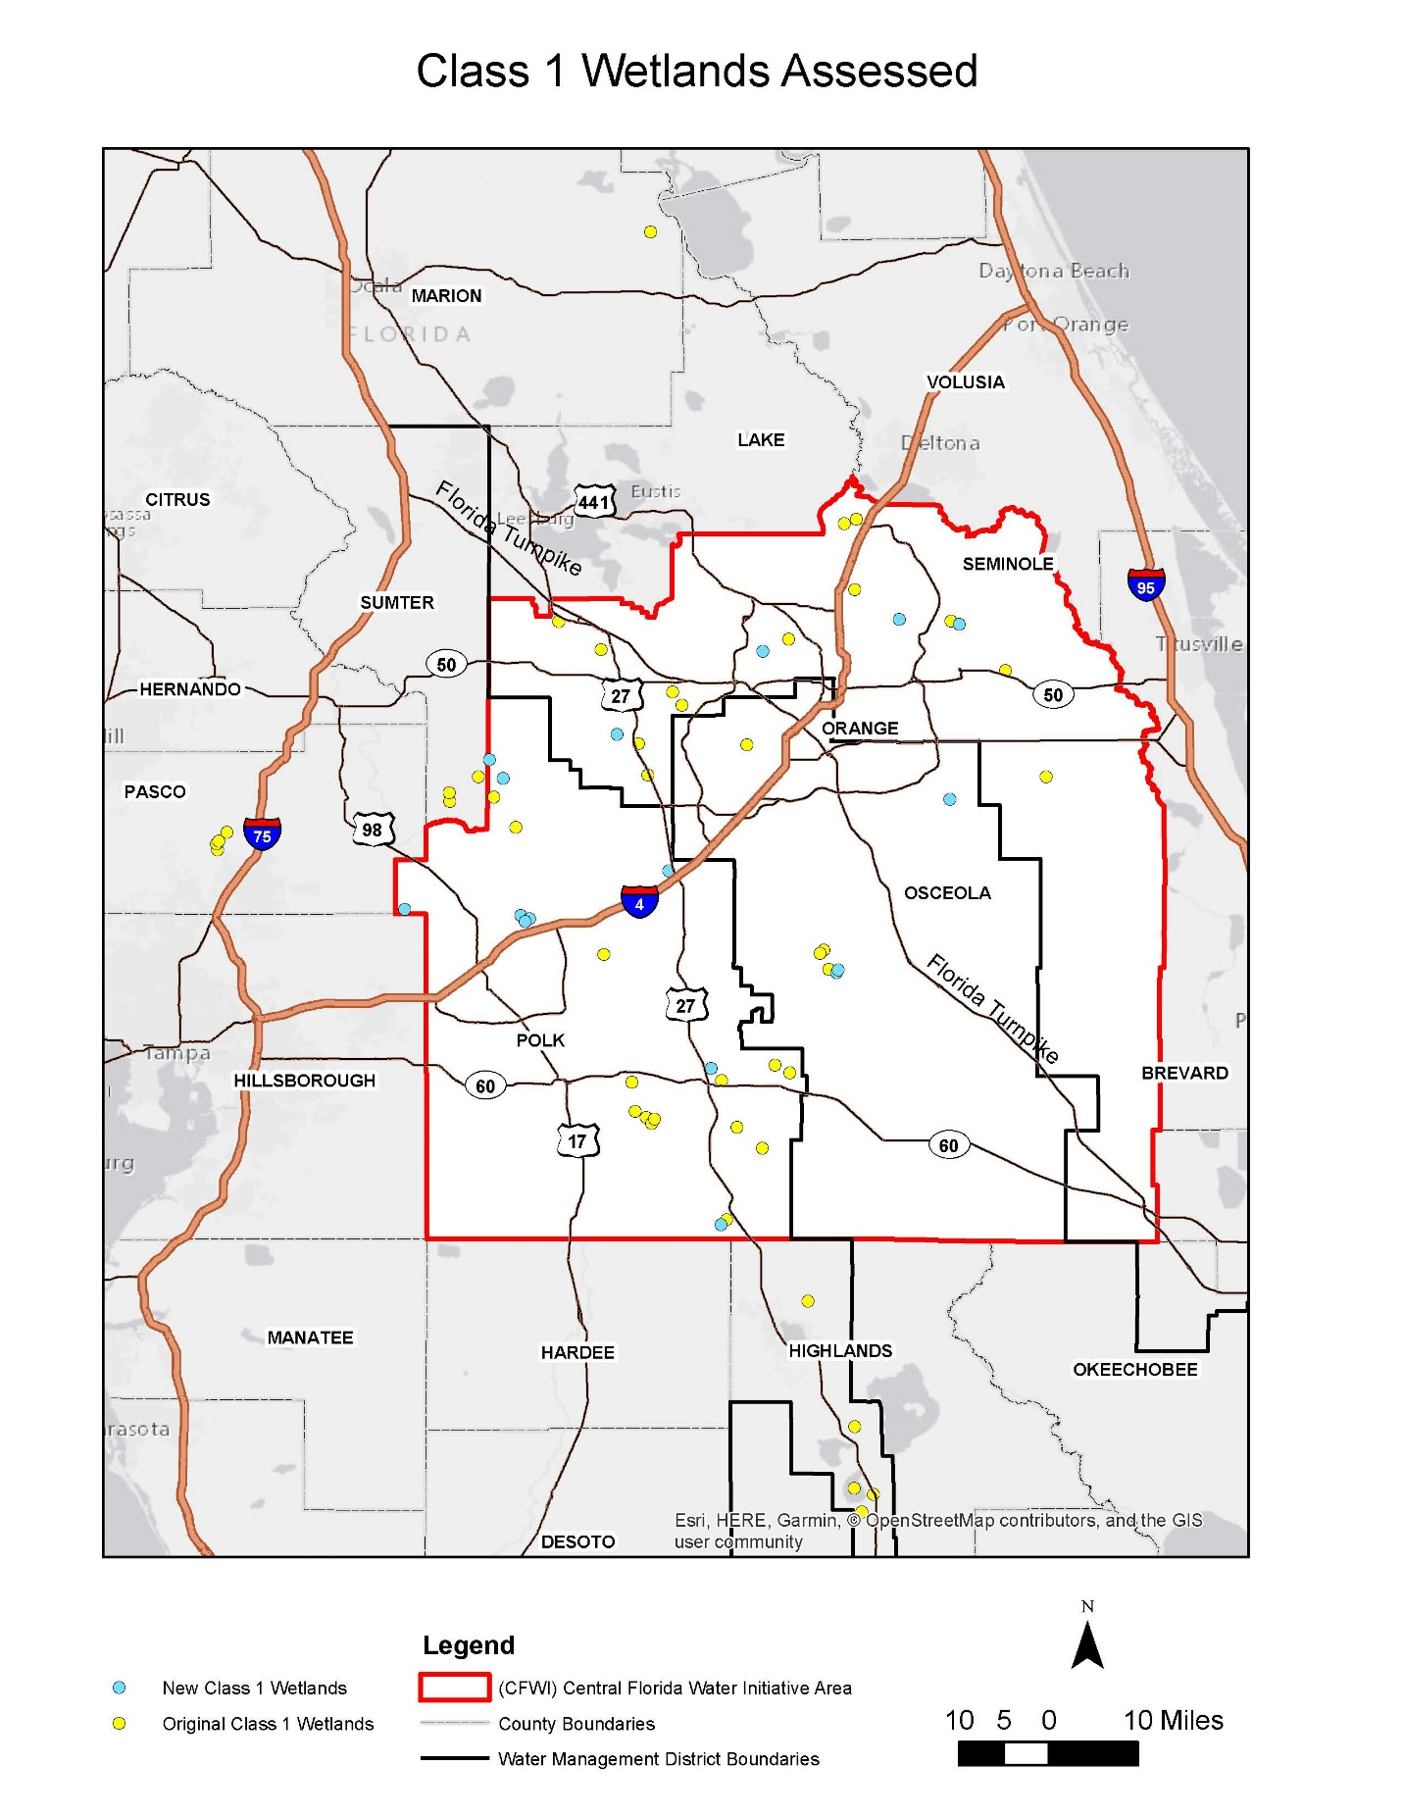

**Figure 1. Locations of the Class 1 wetlands included in the final, expanded dataset, which includes 41 of the original 44 wetlands and 15 new wetlands. NEW MAP IS BEING CREATED**

**3.1 Change in Stress Status of Original Class 1 Wetlands**

The current stress status determination for 11 of the original 44 Class 1 wetlands was different than that determined during the original evaluation, representing 25% of the original dataset (Figures 2 and 3 and Appendix C). The status of five Plains wetlands changed from Stressed to Not Stressed, and one Plains lake changed status from Not Stressed to Stressed. Four Ridge wetlands changed status from Stressed to Not Stressed, while one Ridge lake changed status from Not Stressed to Stressed. Note that these changes may not be due to a change in the condition of the site but rather to a change in how current stress was determined.

In the original evaluation, there were limited instances in which the field observations did not align with review of historic aerials or direct personal knowledge of the system in question. In those instances, due to the inconsistency noted in the field evaluations, the stress determination may have been made based solely on review of those additional factors. During the 2018 re-evaluation, if the observations made in the field were in conflict with the previous status determination, additional evaluations of existing hydrologic and aerial imagery was used to either support or refute the current field observations but was not used as the sole determinant of wetland stress.

The majority of Class 1 wetlands (9 of eleven) that changed stress status changed from Stressed to Not Stressed. Some of these wetlands appear to be recovering from hydrologic stress, including two wetlands within the Cypress Creek Wellfield, which has undergone significant reductions in groundwater withdrawals since the prior assessment. However, for some of the wetlands, the change in stress status is due to a change in how the EMT evaluated the factors in determining stress (e.g., the original assessors may have based their determination on historical aerials that were not representative of recent conditions). In addition, for some of the wetlands, it was not possible to determine the reason for the Stressed status determination was made in the original assessment.

Two lakes changed stress status from Not Stressed to Stressed, most likely as a result of the change in how the EMT evaluated factors in determining stress. It is not clear why Lake Sylvan was classified as Not Stressed during the original assessment; however, visible signs of hydrologic stress (e.g., pines encroaching well into the lake, soil subsidence) were observed during both recent non-related evaluations and the 2018 EMT assessment. For Gator Lake, the original assessment conducted in May 2012 did not indicate observations of signs of hydrologic stress; however, the 2018 evaluation was conducted in a location where due to land management practices, the ecotone is less disturbed and the stress indicators may be more clearly expressed.

In addition to Lake Sylvan and Gator Lake, the Class 1 wetlands that changed stress status included Tibet Butler, Lake Gem, Island Lake, Cypress Creek #190 E Marsh, Cypress Creek #211 W33, Lake Wales, Big Gum Lake, Polecat Lake, and Crooked Lake (Table 2). A detailed analysis of water level data for the period of record selected for the EMT wetlands analysis (see Section 4) for Lake Gem, Island Lake, and Cypress Creek #190 E Marsh indicated that these wetlands were outliers and not representative of isolated wetlands in the CFWI planning area; therefore, these three wetlands were not included in the final, expanded Class 1 wetlands dataset for the analysis in support of the 2020 CFWI RWSP. Details regarding the change in stress status for each of the wetlands are described in Appendix B.

**Table 2. Site descriptions of the original Class 1 wetlands in which stress status changed.**

|  |  |  |  |  |  |
| --- | --- | --- | --- | --- | --- |
| **Site Name** | **Wetland or Lake** | **Plains or Ridge** | **Original Status** | **Current Status** | **Comments** |
| Tibet Butler | Wetland | Plains | Stressed | Not Stressed | Increasing water level trend, no observed field indicators of stress |
| Lake Gem1 | Lake | Plains | Stressed | Not Stressed | Reduction in upper limit of water level due to existing ditch, no observed field indicators of hydrologic stress |
| Island Lake1 | Wetland | Plains | Stressed | Not Stressed | Original determination based on historic imagery, no current field indicators of hydrologic stress |
| Lake Sylvan | Lake | Plains | Not Stressed | Stressed | Decreasing water level trend, observed field indicators of hydrologic stress |
| Cypress Creek #190 E Marsh1 | Wetland | Plains | Stressed | Not Stressed | Cypress Creek Wellfield withdrawal reductions, increasing water level trend |
| Cypress Creek #211 W33 | Wetland | Plains | Stressed | Not Stressed | Cypress Creek Wellfield withdrawal reductions, increasing water level trend |
| Lake Wales | Lake | Ridge | Stressed | Not Stressed | Stable water level trend, no field indicators of hydrologic stress |
| Big Gum Lake | Lake | Ridge | Stressed | Not Stressed | Stable water level trend, no observed field indicators of hydrologic stress |
| Gator Lake | Lake | Ridge | Not Stressed | Stressed | Observed field indicators of hydrologic stress |
| Polecat Lake | Lake | Ridge | Stressed | Not Stressed | No observed field indicators of hydrologic stress |
| Crooked Lake | Lake | Ridge | Stressed | Not Stressed | Increasing water level trend, removal of direct withdrawals, nearby withdrawal reductions |

1: Not included in final, expanded Class 1 dataset

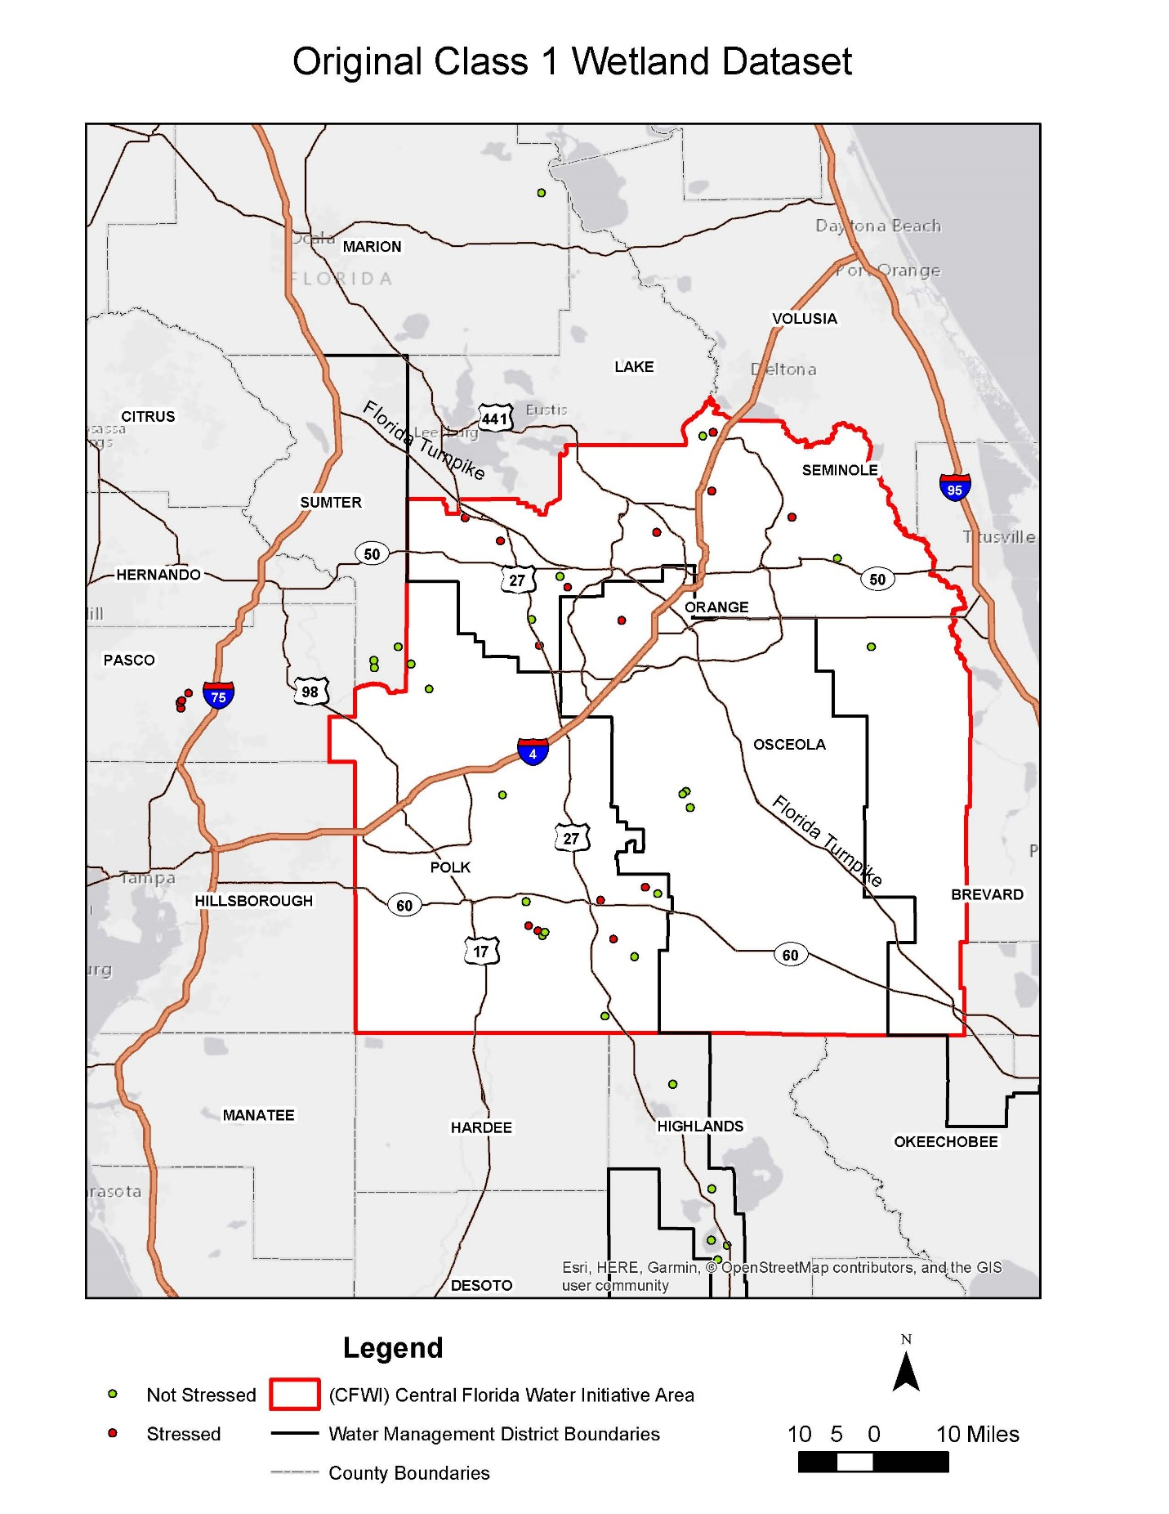

**Figure 2. Stress status of the original 44 Class 1 wetlands for the 2015 CFWI RWSP. Note that 3 of these Class 1 wetlands are not included in the analysis for the 2020 CFWI RWSP. NEW MAP IS BEING CREATED**

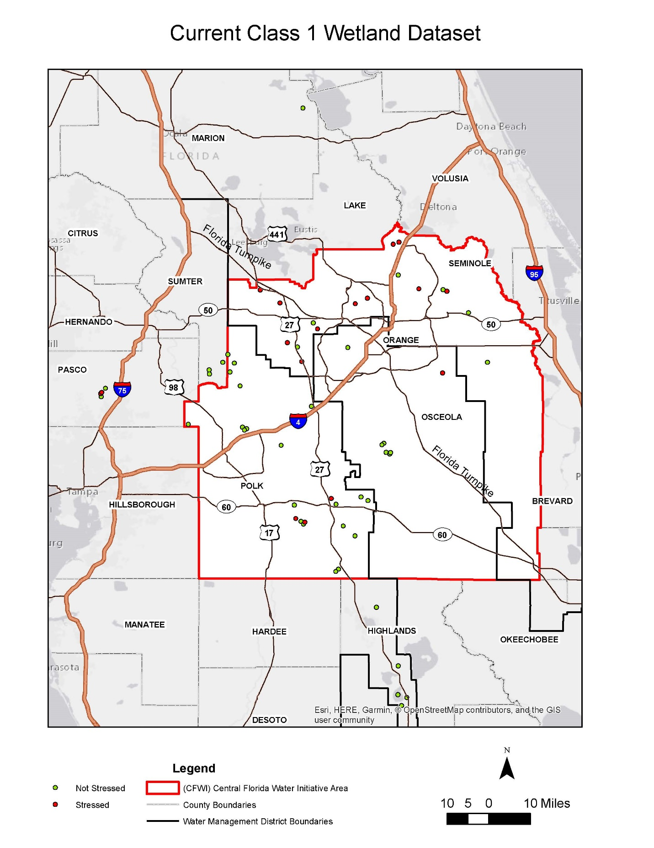

**Figure 3. Current stress status of the 56 Class 1 wetlands included in the analysis for the 2020 CFWI RWSP. NEW MAP IS BEING CREATED**

**3.2 Description of New Class 1 Wetlands Assessed**

Field assessments of 16 new Class 1 wetlands were conducted to determine their stress status, and analyses of the long-term water level data were conducted to determine if these sites were suitable for inclusion in the expanded Class 1 wetland dataset for the EMT wetland analyses. Information for each of the new Class 1 wetlands can be found in Appendix B. An analysis of water level data for the period of record selected for the analysis (see Section 4) for Prairie Lake, a stressed Ridge wetland, indicated that it is an outlier and not representative of isolated wetlands in the CFWI planning area; therefore, this site was not included in the Class 1 wetlands dataset.

The final, expanded Class 1 wetlands dataset for the EMT wetlands analysis in support of the 2020 CFWI RWSP includes 15 Class 1 wetlands. Twelve of the new Class 1 wetlands are Plains wetlands; the assessments indicated that nine are currently Not Stressed, while three are Stressed. The three new Ridge Class 1 wetlands include one Not Stressed wetland and two sites determined to be Stressed. The new Class 1 wetlands, as well as excluded Prairie Lake, are described in the following paragraphs.

**3.3 Final, Expanded Class 1 Wetland Dataset for Analysis**

The Class 1 wetlands dataset used for the analysis in support of the 2015 CFWI RWSP included 18 Plains wetlands and 26 Ridge wetlands. For the 2020 update to the RWSP, the Class 1 wetlands dataset includes 28 Plains wetlands and 28 Ridge wetlands (Table 3). While the sample size of the Class 1 wetlands dataset increased from 44 to 56 for the current analysis, the ratio of Not Stressed to Stressed wetlands has changed, particularly for Plains wetlands (Table 3). Compared to the original dataset, the number of Not Stressed Plains wetlands has more than doubled in the expanded Class 1 wetlands dataset, while the number of Stressed Plains wetlands has decreased. The distribution of the Ridge wetlands in the current Class 1 Ridge wetlands dataset is fairly similar to the 2015 dataset.

**Table 3. Comparison of the Not Stressed/Stressed Class 1 wetlands for the analyses in support of the 2015 and 2020 CFWI RWSPs.**

|  |  |  |  |  |
| --- | --- | --- | --- | --- |
| **Wetland Type** | **For 2015 RWSP EMT Analysis** | | **For 2020 RWSP EMT Analysis** | |
|  | **Not Stressed** | **Stressed** | **Not Stressed** | **Stressed** |
| Plains | 10 | 8 | 21 | 7 |
| Ridge | 15 | 11 | 19 | 9 |
| **Total** | **25** | **19** | **40** | **16** |

# 4.0 Determination of Class 1 Wetlands Water Level Data Period of Record for Wetlands Analysis

Combine with Section 5?

Add an Appendix to show data details (similar to Attachment G)?

The previous analysis of Class 1 wetlands used water level data with a period of record of six years (2006-2011). The EMT wanted to expand the period of record for the analysis for the 2020 update to the CFWI RWSP. To determine the period of record to use for the analysis without causing the dataset to become non-representative, water level data for each Class 1 wetland from 2006 through 2017 were organized into a spreadsheet. The data were reviewed to remove any incorrect observations. If a wetland had multiple wells and staff gages, the most representative measuring device was selected or data were combined as necessary to create the most representative long-term record. For each Class 1 wetland, the P80 (80% of the water level readings exceed the P80), for water level data from 2006 through 2011 was calculated. New years of data (2012, 2013, 2014, 2015, 2016, and 2017) were added one year at a time, and P80s were calculated for each Class 1 wetland to determine how much change occurred as a result of adding in the additional year. After the results were reviewed, the period of record from 2009 through 2017, a nine-year period of record, was selected.

Need to add some figures that show (put details in Appendix and present some summary figures here):

Water level data for each wetland from 2009 through 2017

Some representative figures as examples of P80 calculations when years were added

**4.1 Period of Record Rainfall**

For comparison to the Class 1 wetlands water level data, as well as for comparison to the ECFTX model calibration period (2003-2014), rainfall data from 2009 through 2017 were summarized from representative locations in the CFWI planning area (Table X).

**Table X. Rainfall Monitoring Stations Examined in the CFWI Planning Area.**

|  |  |  |  |  |
| --- | --- | --- | --- | --- |
| **Site ID** | **Site Name** | **Longitude** | **Latitude** | **WMD** |
| **15323/SHING.RG** | Shingle Creek Swamp Rain Gauge | -81.450344 | 28.377505 | SF |
| **FF846/WRWX** | Walker Ranch Weather Station (Disney Wilderness Preserve) | -81.399830 | 28.048727 | SF |
| **28765084** | Lake Louisa State Park at Clermont | ‐81.723000 | 28.455000 | SJR |
| **7982** | Sanford | ‐81.266700 | 28.800000 | SJR |
| **USW00012815** | Orlando International Airport | ‐81.325000 | 28.433900 | SJR |
| **25147** | Mountain Lake NWS | ‐81.599236 | 27.938631 | SWF |
| **17350** | ROMP 88 Rock Ridge | ‐81.906739 | 28.309450 | SWF |

Add figures and text on rainfall data here

# 5.0 Wetlands Analysis

Include details here or update Attachment H?

For the 2015 CFWI RWSP, the EMT’s analysis of the potential impacts of future groundwater withdrawals on wetlands included two steps based on the dataset from the Class 1 wetlands (CFWI EMT 2013):

* An analysis of water level data from the Class 1 wetlands to compute a statistical relationship between observed stress and observed P80 water level variations was conducted. The statistical relationship was used to estimate the probability (or risk) of future changes in wetland stress occurring, based on modeled water level changes between the reference condition and a future groundwater withdrawal scenario. This risk assessment was applied separately to primarily isolated wetlands in Plains and Ridges physiographic settings because wetland hydrologic conditions in these wetlands, in general, are substantially different. Statistical analyses were performed, which indicated that the characteristics of the Class 1 wetlands were representative of all isolated wetlands in the CFWI planning area and that the data used were appropriate for their application.
* An assessment of modeled future water level changes at all known wetland sites in the CFWI planning area was performed, and the risk for wetland stress occurrence at each location was calculated. The probability of change in wetland stress status (from unstressed to stressed, or the reverse) was calculated for each wetland location, based on the risk function calculated in Step 1. The expected total area of stressed wetlands was calculated for the whole CFWI planning area by summing the effects of water level changes and recorded wetland areas throughout the CFWI planning area. This set of tools was used by the GAT to predict likely effects of groundwater withdrawals, as predicted by modeled water levels, on wetland resources.

As was discussed earlier, the methodology described above was used to assess the potential impacts of future groundwater withdrawals on isolated wetlands and lakes for the 2020 update to the CFWI RWSP. Using the P80 water levels that were calculated for each Class 1 wetland for the selected period of record (2009-2017), the Class 1 wetland statistics (e.g., mean, standard deviation of P80 water levels) for each wetland group (Stressed and Unstressed) and each physiographic province (Plains and Ridge) were updated and evaluated for normal distributions. In order to conduct the wetland stress analysis, the risk analysis equations for Plains and Ridge wetland systems were revised in order to conduct the wetland stress analysis. The stress risk algorithm that was developed for post-processing of the ECFT model results was revised to incorporate the updated statistical risk equations and for compatibility with the ECFTX model output files.

* Post-process the ECFTX model runs:
  + Calculate the probable stressed and unstressed wetland acreage for each ECFTX model cell in the reference condition (2014) and calculate the probable change in stressed and unstressed wetland acreage for each ECFTX model cell under the simulated future conditions (2030 and 2040 conditions).
  + Calculate the probable change in total stressed wetland acreage for each model scenario, and prepare tables and maps showing the geographic distribution of projected stressed wetland acreage.
  + Provide tables and maps of results for each model scenario to the GAT.

GIS support was necessary to be able to calculate the probable stressed and unstressed acreage of Class 1, Class 2, and Class 3 wetlands for each ECFTX model cell for each scenario. Specifically:

* For Class 1 wetlands: GIS processing was conducted to create a single polygon of each site by merging the polygons of different wetland types.
* Since Class 2 wetlands were not re-evaluated and no new Class 2 wetlands were added to the dataset, the GIS layer used for the analysis in support of the 2015 CFWI RWSP could be used for the current analysis.
* For Class 3 wetlands: GIS processing was conducted to calculate the acreage of Class 3 wetlands in the western portion of the CFWI planning area not included in the previous modeling effort.
* The acreages of Class 1, Class 2, and Class 3 stressed and unstressed Plains and Ridge wetlands in each ECFTX model cell was calculated.

# 6.0 Summary

# 7.0 References

CFWI (Central Florida Water Initiative) Environmental Measures Team (EMT). 2013. Development of Environmental Measures for Assessing Effects of Water Level Changes on Lakes and Wetlands in the Central Florida Water Initiative Area. Central Florida Water Initiative’s Environmental Measures Team, Final Report, November 2013.

# Appendices

# Appendix A:

# Field Form Used for the

# 2018 Class 1 Wetlands Assessments

**WETLAND ASSESSMENT FIELD FORM – CFWI**

Revised 02-13-18

Date: ____________________ Evaluators: ___________________________________________

Site Name/ID: __________________________________________________________________

Wetland Type: Class 1 Class 2 Class 3 District: SFWMD SJRWMD SWFWMD

GPS Coordinates or Lat/Long: _____________________________________________________

**Wetland/Lake Characteristics (Take Multiple Representative Photos)**

Lacustrine or Palustrine Isolated Interconnected Seepage Slope Sandhill

Topographic Relief: Relatively Flat (0-2’) Moderate (3-5’) Extreme (>5’)

Vegetation Zonation: Well Defined Somewhat Defined Poorly Defined

Zones Present: Transitional Zone Outer Deep Zone Deep Zone

Presence of Water in Wetland: Dry Saturated Inundated Center Throughout

If Lake, Description of Water Level: Normal Above Normal Below Normal

**Habitat Characteristics (Circle Those Present and Take Representative Photos)**

Shifts and Change in Plant Communities Invasion by Upland Species

Presence of Nuisance or Invasive Species Dead or Dying Vegetation/Trees

Premature Leaf Falls Discolored Foliage Leaning Trees Tree Falls

Absence of Regeneration of Wetland Species Exposed Tree Roots

Age Class Differences of Trees Evidence of Recruitment of Wetland Tree Species

Fire Scars Evidence of Logging Cattle

Overall Habitat Condition: Excellent Good Fair Poor

Justification of Condition (Based on Characteristics): ____________________________________

______________________________________________________________________________  
______________________________________________________________________________  
______________________________________________________________________________

**Soil Characteristics at Wetland Boundary (Take Representative Photos)**

Soil Type: Sand/Mineral Peat Muck Hydric Inundated Saturated Moist Dry

Soil Subsidence/Oxidation: None Yes Measured Depth: __________

Soil Fissures: None Yes Measured Depth: __________

Soil Compaction: None Yes Measured Depth: __________

**Hydrologic Indicators (Circle Those Present and Take Photos of Each)**

Pine Edge Saw Palmetto Edge Saw Palmetto “Horses” (Elevated Trunks)

Moss Collars Lichen Lines Stain Lines Adventitious Roots

Buttressed Tree Trunks Cypress Inflection Points Algal Mats Water Marks Rafted Debris Crayfish Burrows Water Lines on Docks/Pilings None

Drainage Alteration in Wetland: None Yes Description: ______________________________

______________________________________________________________________________  
______________________________________________________________________________  
Drainage Alteration of Surrounding Lands: None Yes

Approx. Distance and Description: __________________________________________________

______________________________________________________________________________  
______________________________________________________________________________  
Stormwater Inflows: None Yes Description: _______________________________________

______________________________________________________________________________

**Overall Condition of Wetland: Stressed Not Stressed**

**Photograph Information:**

____________________________________________________________________________________  
________________________________________________________________________________________________________________________________________________________________________  
________________________________________________________________________________________________________________________________________________________________________  
_______________________________________________________________________________________________________________________________________________________________________  
________________________________________________________________________________________________________________________________________________________________________  
________________________________________________________________________________________________________________________________________________________________________  
________________________________________________________________________________________________________________________________________________________________________  
________________________________________________________________________________________________________________________________________________________________________  
________________________________________________________________________________________________________________________________________________________________________  
________________________________________________________________________________________________________________________________________________________________________  
________________________________________________________________________________________________________________________________________________________________________  
____________________________________________________________________________________  
________________________________________________________________________________________________________________________________________________________________________

**Additional Comments:**

____________________________________________________________________________________________________________________________________________________________________________________________________________________________________________________________  
________________________________________________________________________________________________________________________________________________________________________  
________________________________________________________________________________________________________________________________________________________________________  
________________________________________________________________________________________________________________________________________________________________________  
________________________________________________________________________________________________________________________________________________________________________  
________________________________________________________________________________________________________________________________________________________________________  
________________________________________________________________________________________________________________________________________________________________________  
________________________________________________________________________________________________________________________________________________________________________  
________________________________________________________________________________________________________________________________________________________________________  
________________________________________________________________________________________________________________________________________________________________________  
________________________________________________________________________________________________________________________________________________________________________  
________________________________________________________________________________________________________________________________________________________________________  
________________________________________________________________________________________________________________________________________________________________________

# Appendix B:

# Class 1 Wetlands Information

# Appendix C:

# Class 1 Wetlands Assessment Results